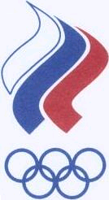
119922, г. Москва, Лужнецкая набережная, 8 8 , Luzhnetskaya nab.,119922, Moscow, Russia
Тел. (095) 725-45-63, Факс (095) 725-45-29 Phone: + 7 095 725-45-63, Fax: + 7 095 725-45-29
E-mail: roc@orc.ru E-mail: roc@orc.ru

ОЛИМПИЙСКИЙ RUSSIAN
КОМИТЕТ РОССИИ OLYMPIC COMMITTEE
________________________________________________________________________________

№ ЛТ- 15/692 «07» сентября 2005 г.

International Badminton Federation
Manor Park Place
Rutherford Way
Cheltenham GL51 9TU
FAX: 44 12422211030
European Badminton Union
Idrasttens Hus
Broendby Stadion 20
2605 Broendby
Denmark
FAX: 45 43 26 2167

Dear colleagues,

Please be advised that on 27 May 2005 Nikulinsky district court of Moscow city rendered a decision to dissolve the Russian Badminton Federation (President - Mr. Vladimir Lifshits), which has entered in legal force.
According to the ROC Statutes the issue concerning the membership of RBF in the Russian Olympic Committee (ROC) is subject for the consideration by the ROC Executive Body and further approval by the ROC Olympic Assembly at the end of 2005.
At the same time the ROC realizes that badminton is the Olympic sports and the Russian Federation in any case should be presented at the international competitions.
Taking in mind the abovementioned circumstances the ROC kindly asks you to accept entries for the international badminton competitions from the National Badminton Federation of Russia (NBFR). NBFR is the body who has an accreditation from the appropriate state authority to hold an official badminton championships in the territory of Russian Federation.
Therewith we also ask you to pay serious consideration to the fact that the RFB was dissolved by the state court decision and can not participate in the civil transactions according to the Russian legislation in the regard of the transfer of the «Russian Open 2005» prize fund to the RFB by the international federation.

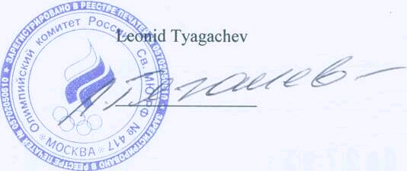
Best regards,

